**Reactive Programming**

Reactive programming is a programming paradigm that deals with asynchronous data streams (sequences of events) and the specific propagation of change, which means it implements modifications to the execution environment (context) in a certain order.

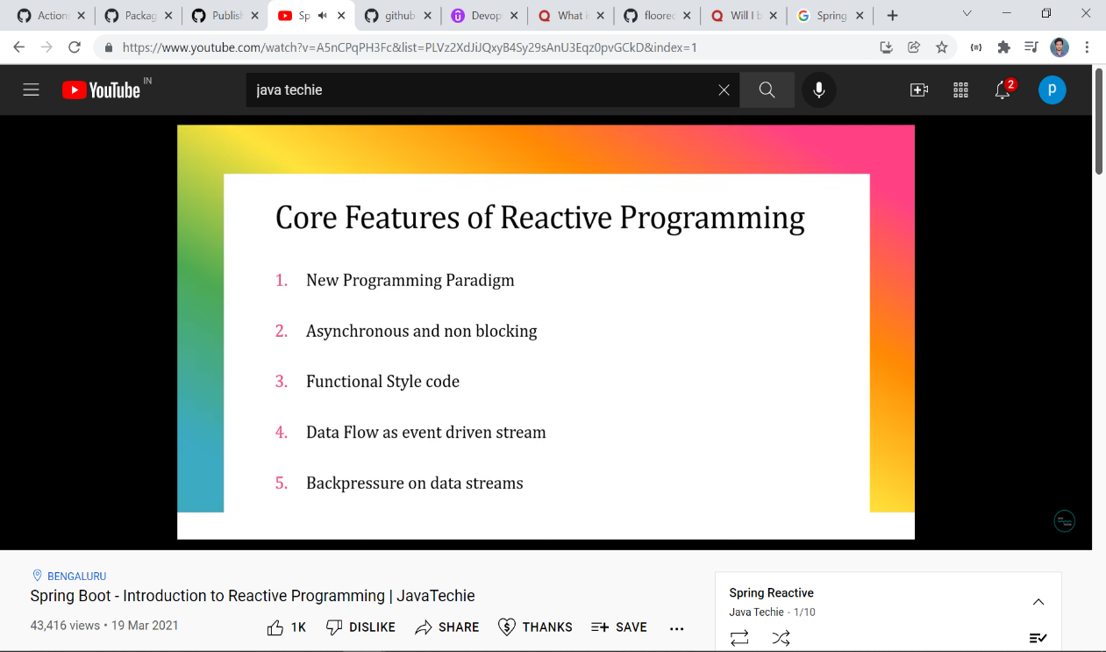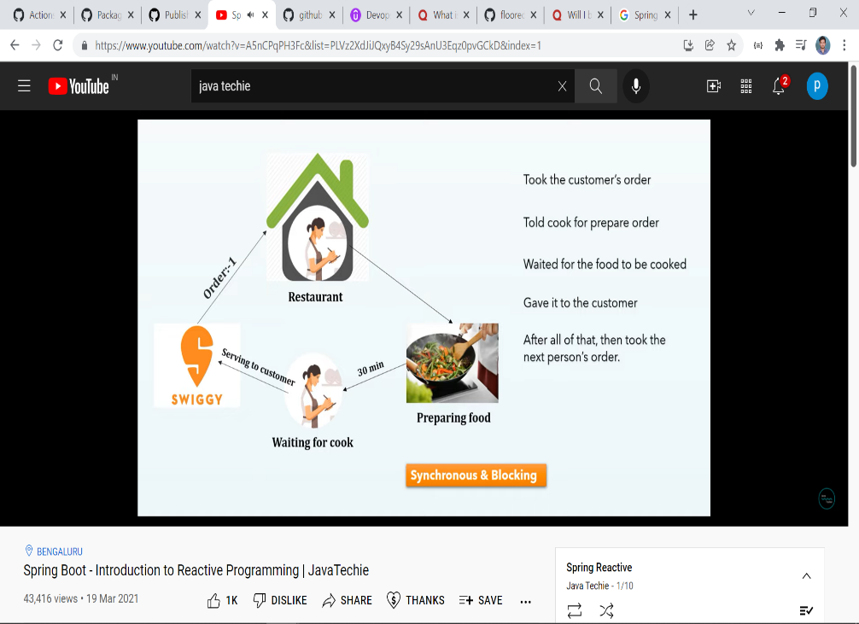

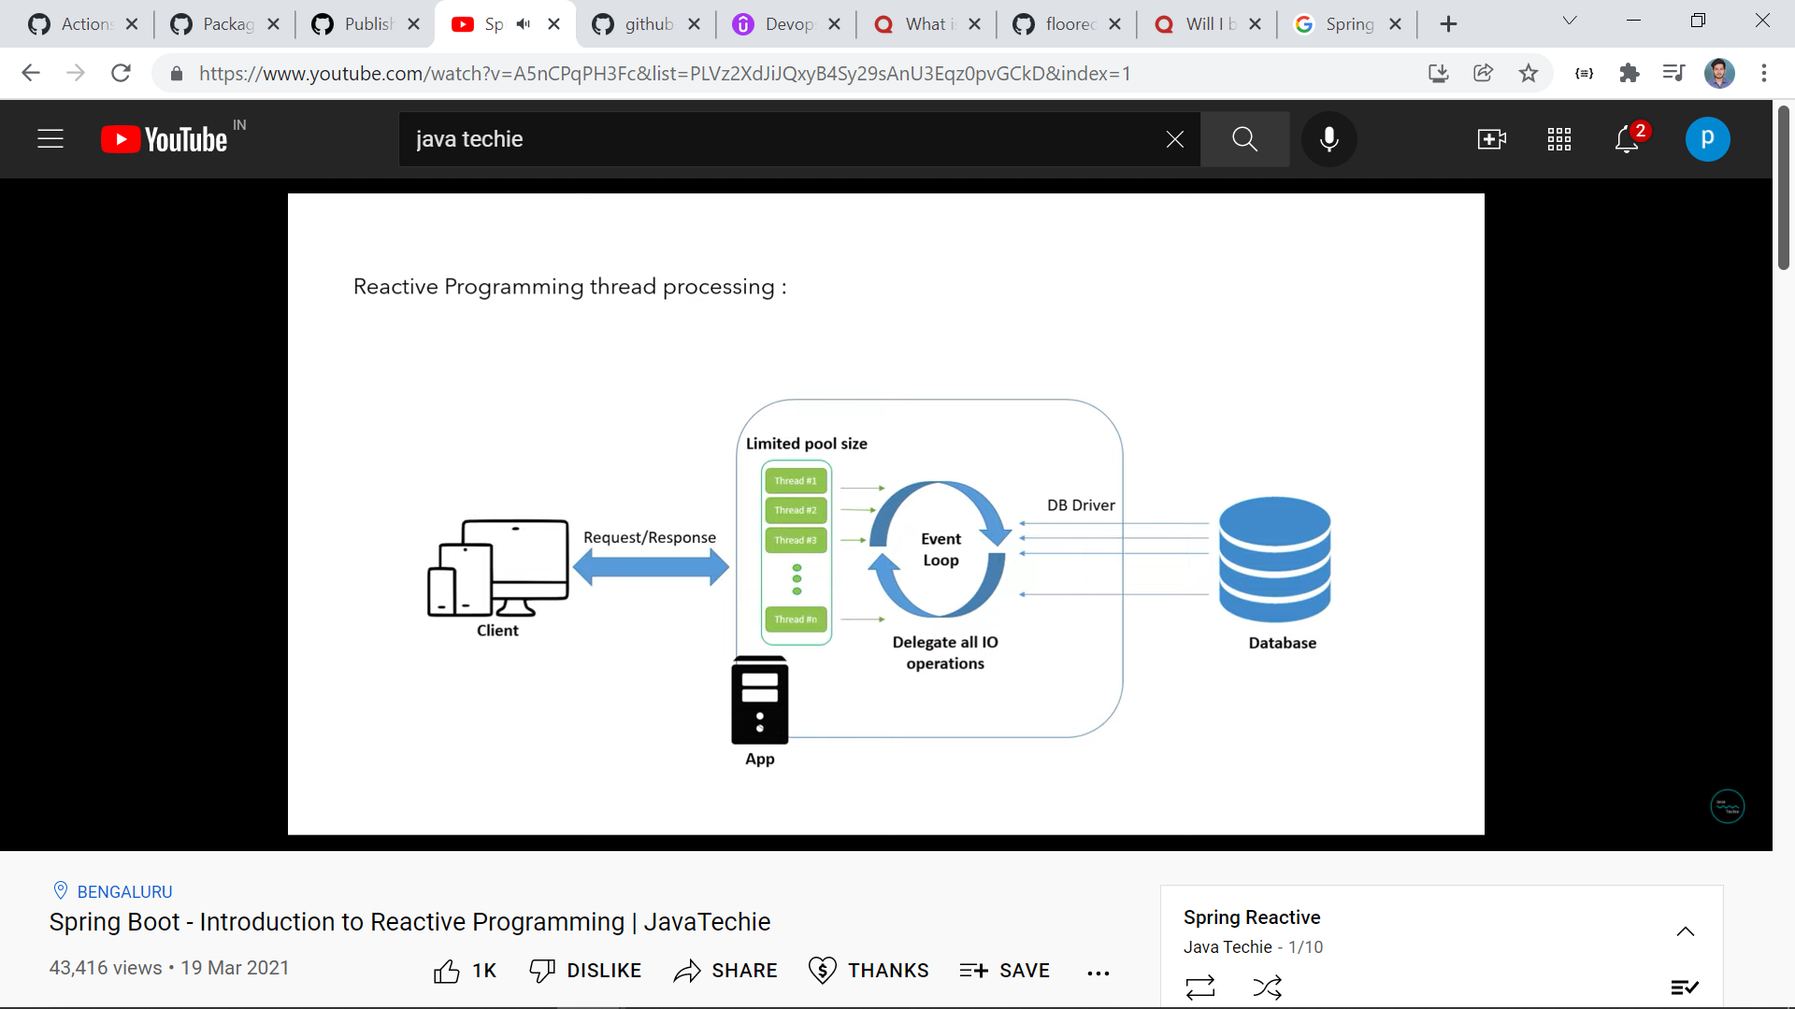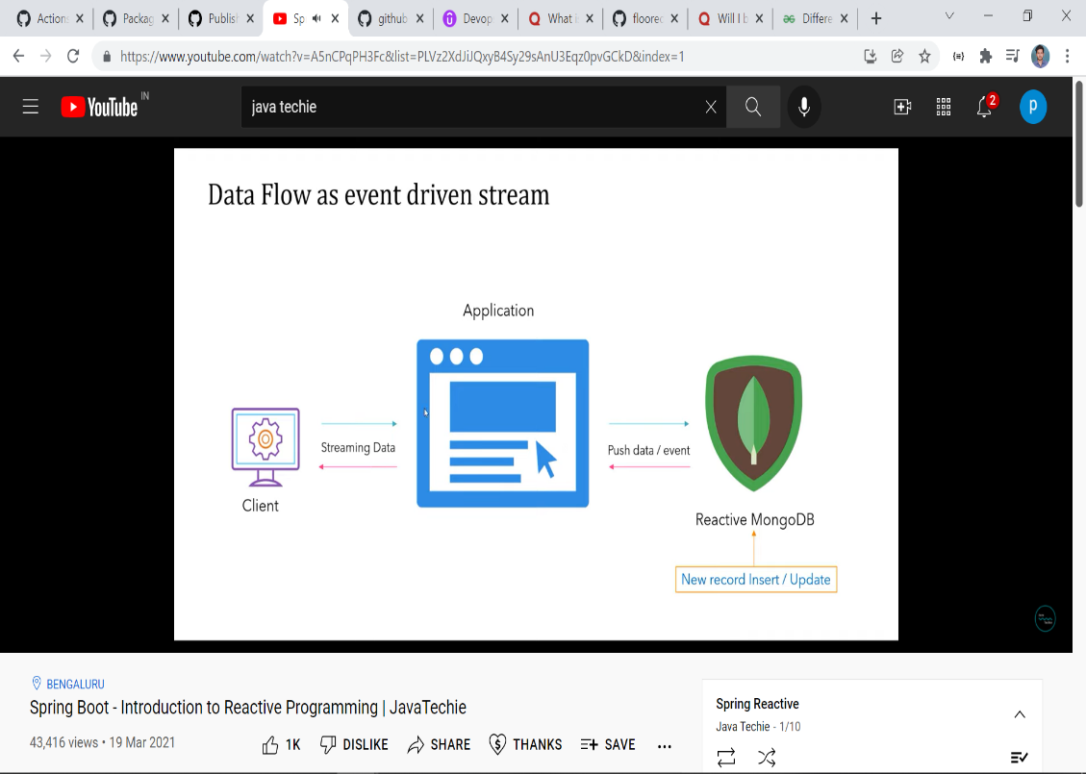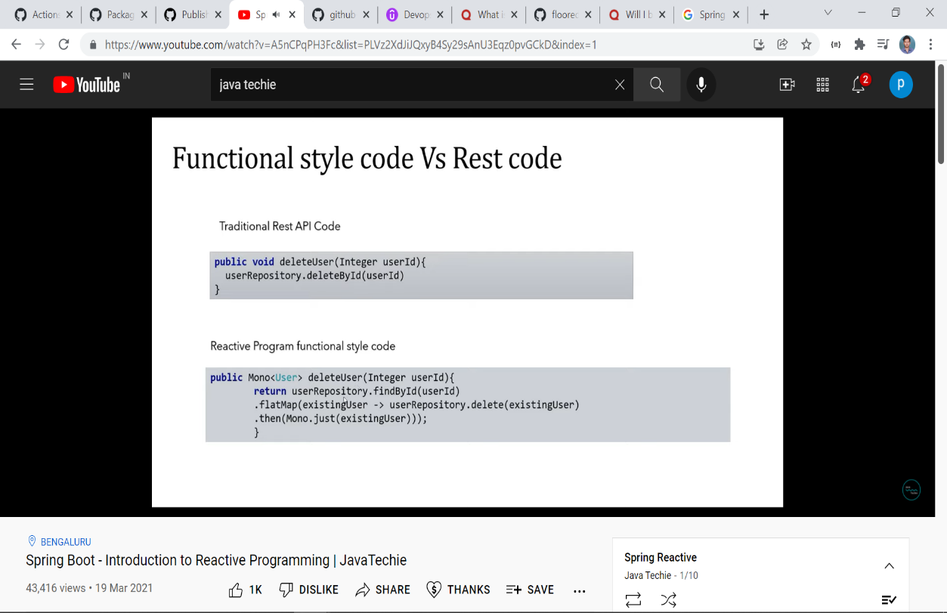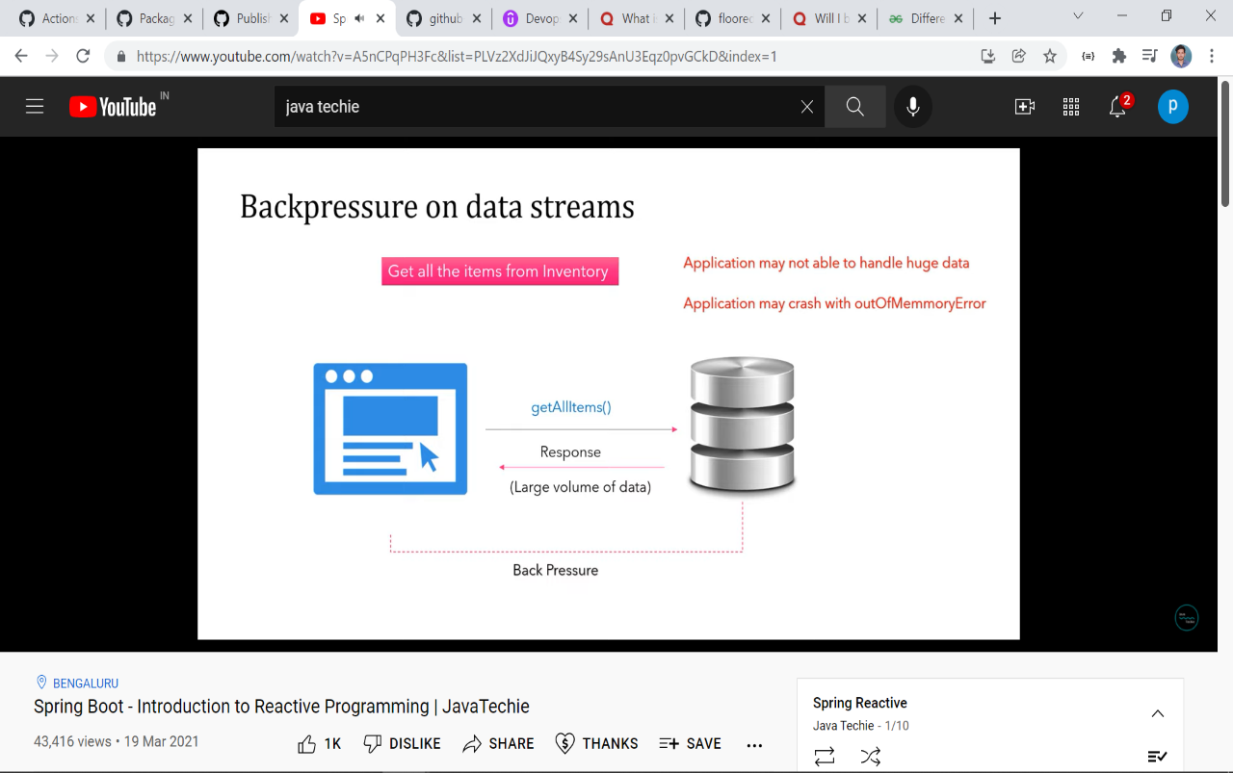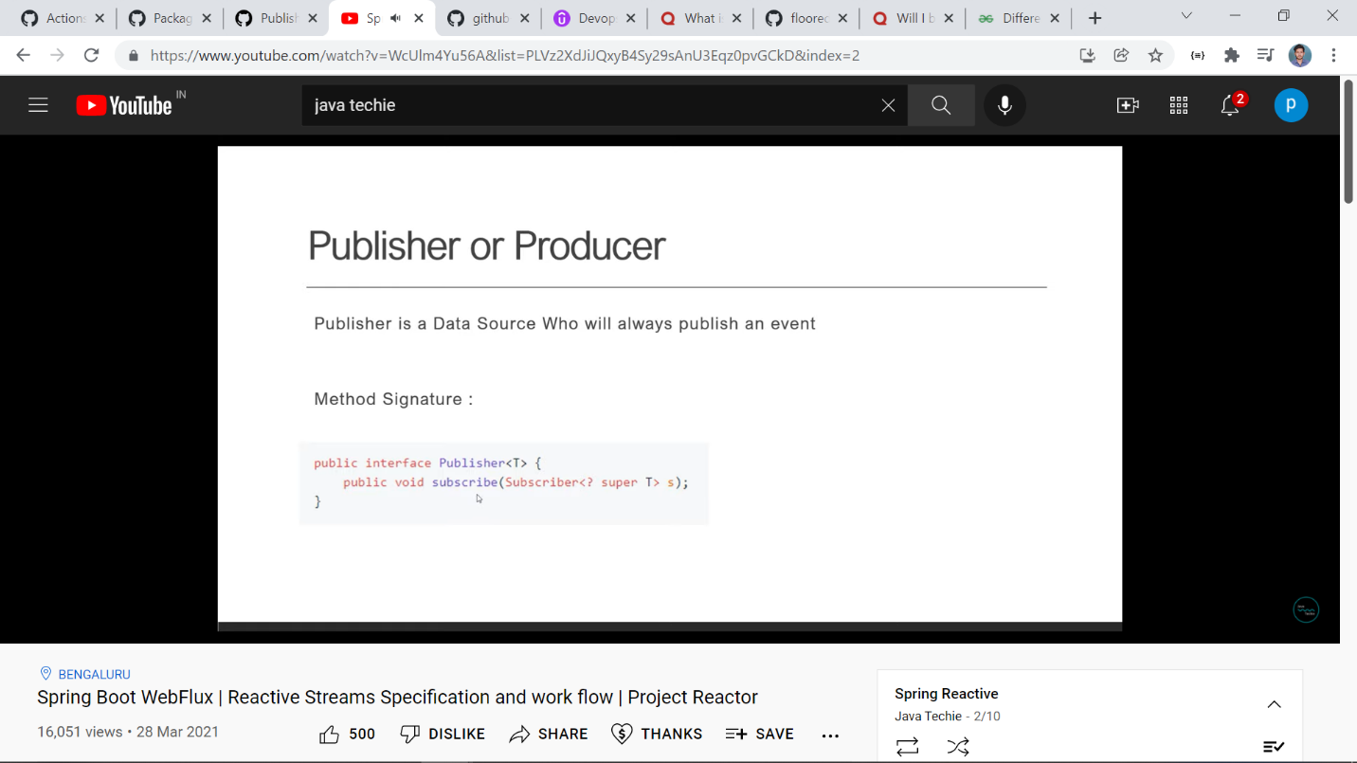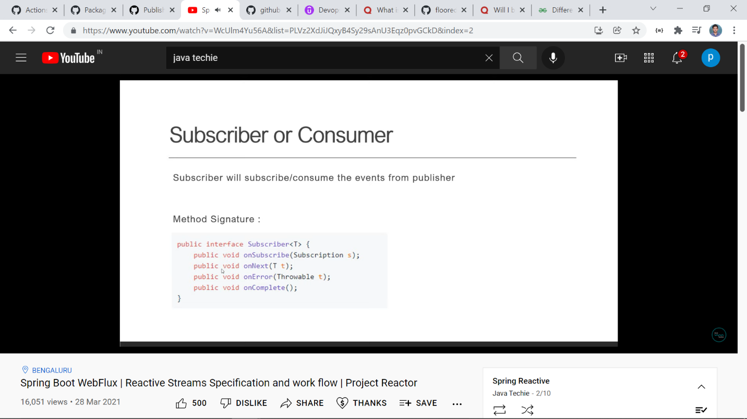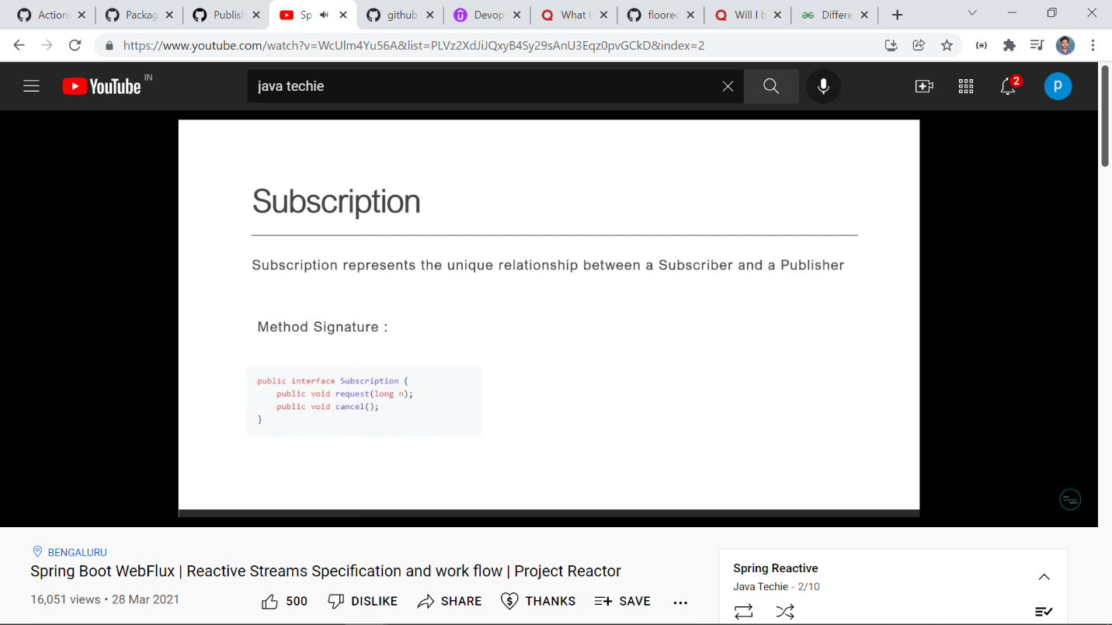

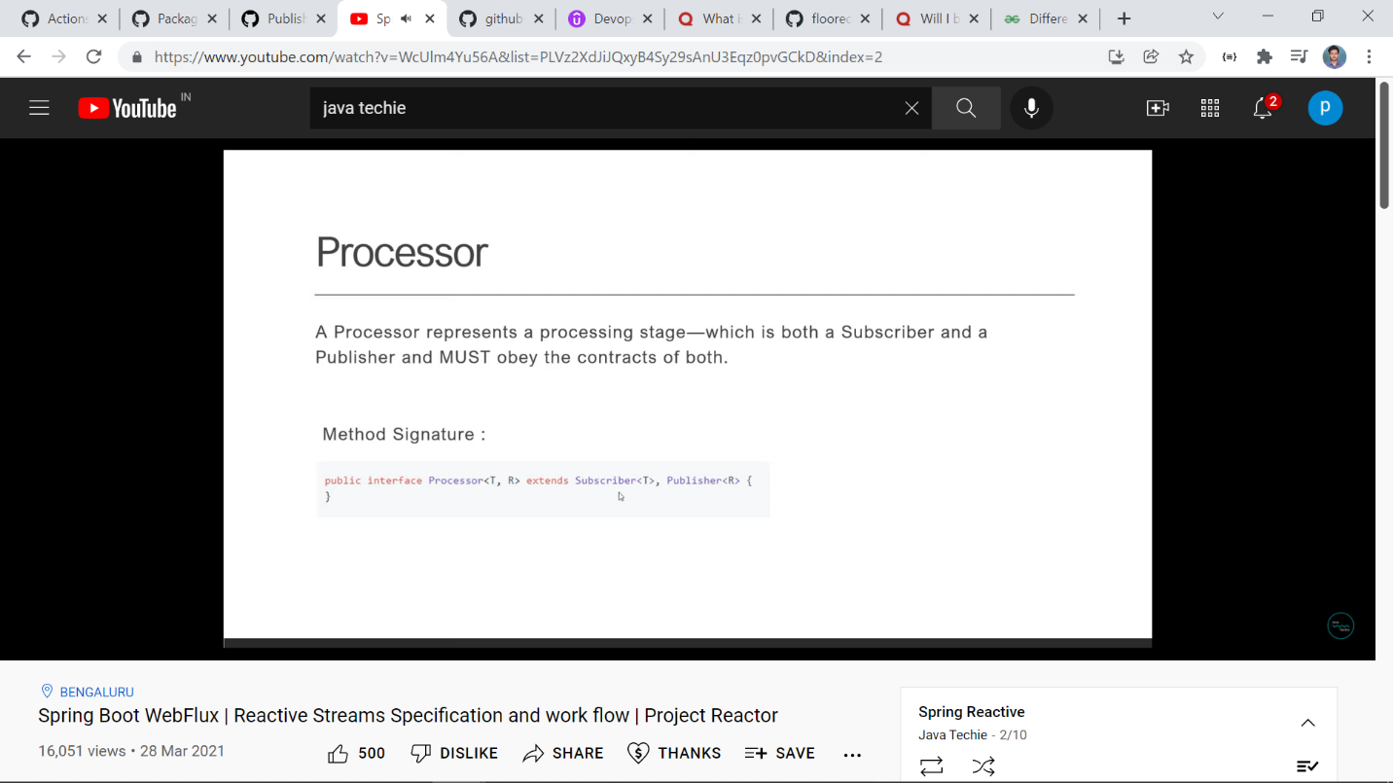

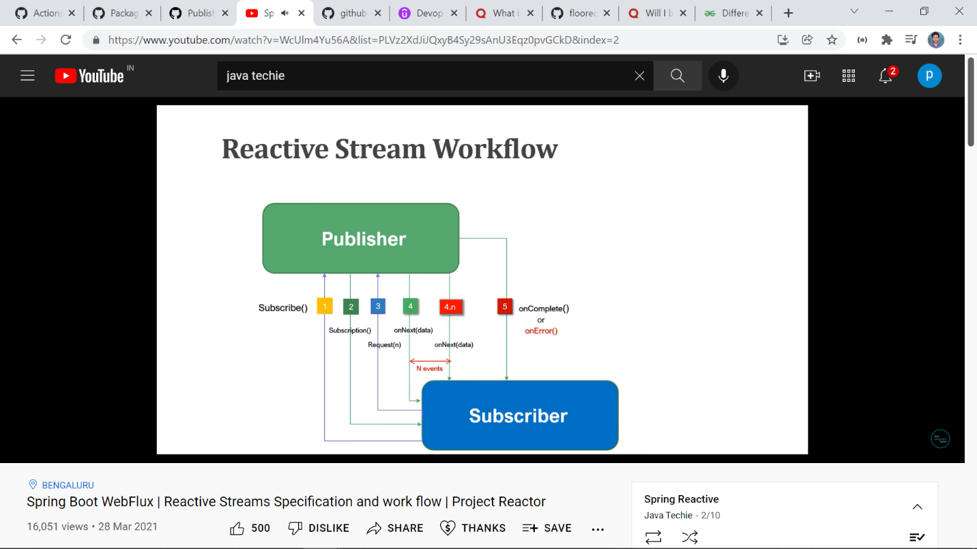

**Event Driven Architecture:**

An event-driven architecture is an architectural paradigm that uses events to trigger and communicate between loosely coupled applications are services. These events needs to be published to an event broker platform and be sent over to consuming applications.

Components of Event Driven Architecture

1) Producers

2) Router

3) Consumers

Producers: Producers are apps or services that publish events to event broker platform

Router: The event router or broker which is a platform or middleware that takes in events and routes them to their respective consuming applications and of course the consumer which is another app or service that consumes to a particular topic in an event router, receives the event or stream of events and does something with it like save the state to the persistent storage or for analytics.

*When design an event driven architecture there is usually two models that we could implement*

1. **Pub/Sub Model**: Events are published to a broker topic and sent over to one or more subscribers. Once received the event cannot be backtraced or reread again and new subscribers do not see the event.

2. **Event Streaming**: Events are written to a log and orderes in a partition. A client application can read from any part of the stream anytime and replay the events.

Benefits of Event-Driven Architecture

1. Asynchronous

2. Scalable and Failure Independent.

3. Auditing and Point-int-time recovery.

**Link for material: https://www.conduktor.io/kafka/kafka-producers**

**Apache Kafka**

Apache Kafka is an open-source, distribute event streaming platform.

<https://www.conduktor.io/kafka/what-is-apache-kafka>

**Topics in Kafka**

A Topic in a kafka is a particular stream of data. A topic is identified by a name. In a kafka cluster there can be many topics. Topics are like a table in database. Any kind of message format. The sequence of messages are called data stream. We cannot query topics, instead use kafka producers to send the data and kafka consumers to read the data.

**Partition and offsets**

Topics are split into partition. This partition contains messages and each message gets an id called offsets. Kafka Topics are immutable, once the data is written to a partition, it cannot be changed.

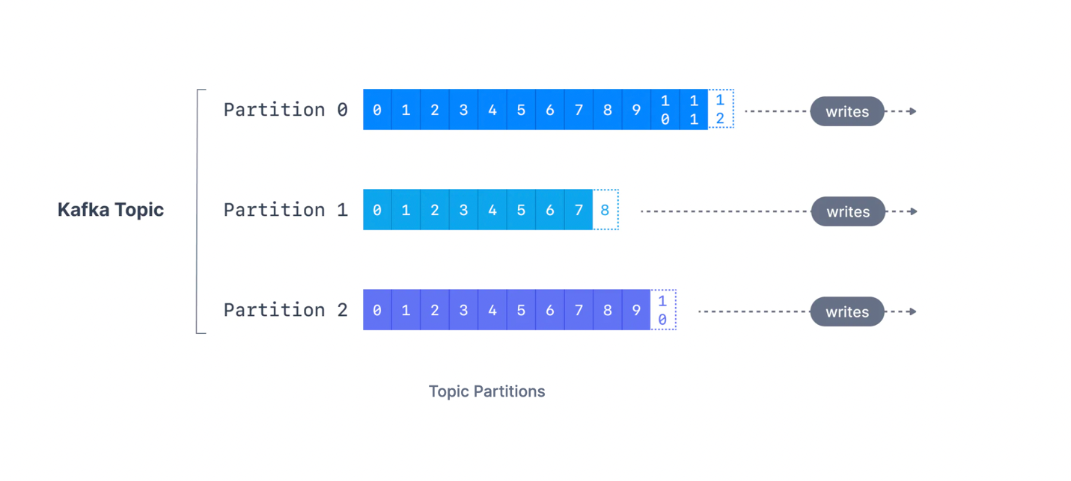

**Producers**

Producers write data to topics(which are made of partitions). Producers know to which partition to write to (and which kafka broker has it). In case of Kafka broker fails, producers will automatially recover.

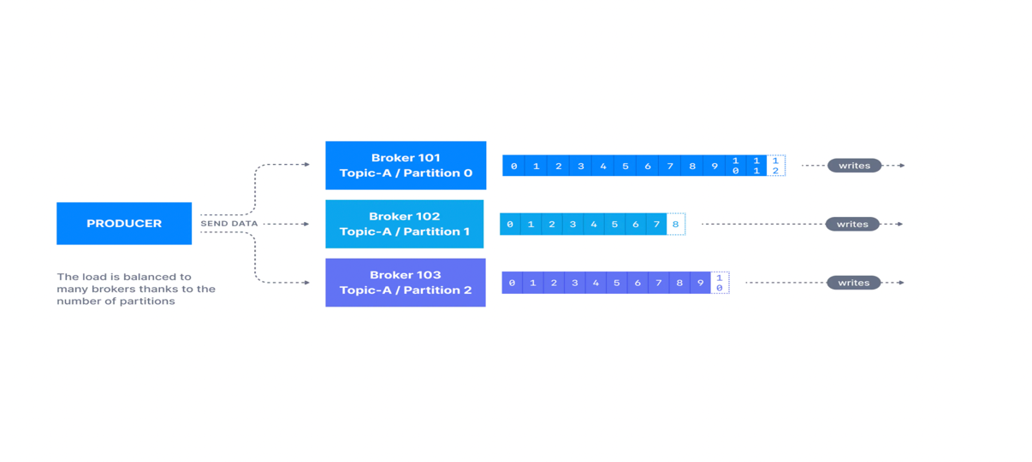

**Producers message keys:**

Producers can choose to send a key with message. If key==null then data is sent around robin(partition 1 or partion 2 etc). If key !=null, then all messages for that key will always end up in same partition. A key is typically send if you need a message ordering for a specific feild.

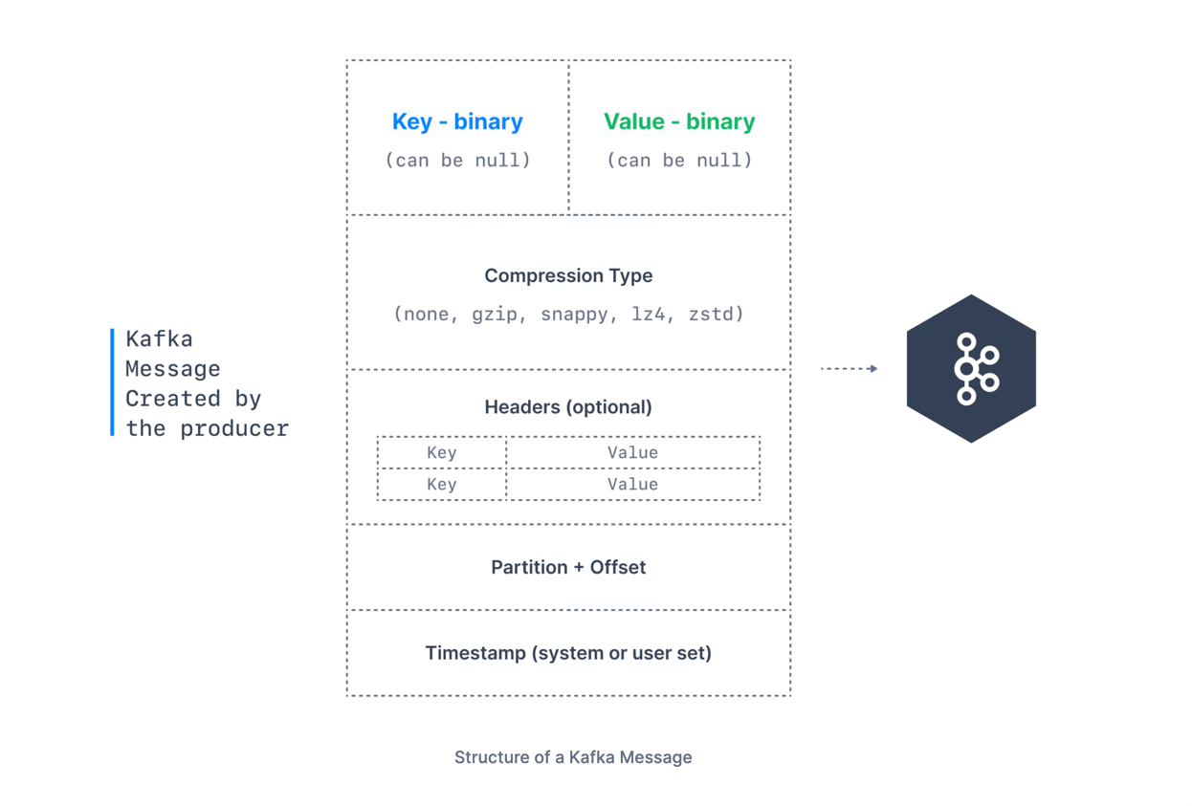

**Kafka Message Serialization**

Kafka only accepts bytes as an input from producers and sends bytes out as an output to consumers. Message Serialization means transforming objects/data into bytes.

**For the curious: Kafka Message Key Hashing**

A Kafka partitioner is a code logic that takes a record and determines to which partition to send it into.

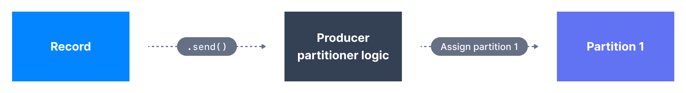

In that effect, it is common for partitioners to leverage the Kafka message keys to route a message into a specific topic-partition. As a reminder, all messages with the same key will go to the same partition. In the default Kafka partitioner, the keys are hashed using the **murmur2 algorithm.**

**Consumers**:

Consumers read data from a topic(identified by a name) - pull model. Consumers automatically knows which broker to read from. In case of broker failure consumers know how to recover. Data is read in order from low to high offset within each partition.

**Consumer Deserializer:**

De-serializing indicates how to convert your binary data in bytes into objects/data. They are used on value and key of the message.

# **Kafka Consumer Groups & Offsets**

**What are Kafka consumer groups and consumer offsets?**

We have seen that consumers can consume data from Kafka topics partitions individually, but for horizontal scalability purposes it is recommended to consume Kafka topics as a group.

## Kafka Consumer Groups

Consumers that are part of the same application and therefore performing the same "logical job" can be grouped together as a Kafka consumer group. A topic usually consists of many partitions. These partitions are a unit of parallelism for Kafka consumers. The benefit of leveraging a Kafka consumer group is that the consumers within the group will coordinate to split the work of reading from different partitions.

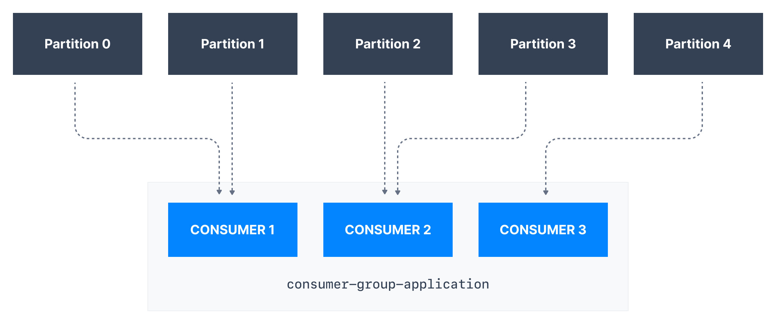

## Kafka Consumer Group ID

In order for indicating to Kafka consumers that they are part of the same specific group , we must specify the consumer-side setting group.id. Kafka Consumers automatically use a GroupCoordinator and a ConsumerCoordinator to assign consumers to a partition and ensure the load balancing is achieved across all consumers in the same group. It is important to note that each topic partition is only assigned to one consumer within a consumer group, but a consumer from a consumer group can be assigned multiple partitions.



In the example above, *Consumer 1* of consumer group *consumer-group-application-1* has been assigned *Partition 0* and *Partition 1*, whereas *Consumer 2* is assigned Partition 2. Only *Consumer 1* receives messages from *Partition 0* and *Partition 1*, while only consumer *Consumer 2* receives messages from *Partition 2*.

Each of your applications (that may be composed of many consumers) reading from Kafka topics must specify a different group.id. That means that multiple applications (consumer groups) can consume from the same topic at the same time:

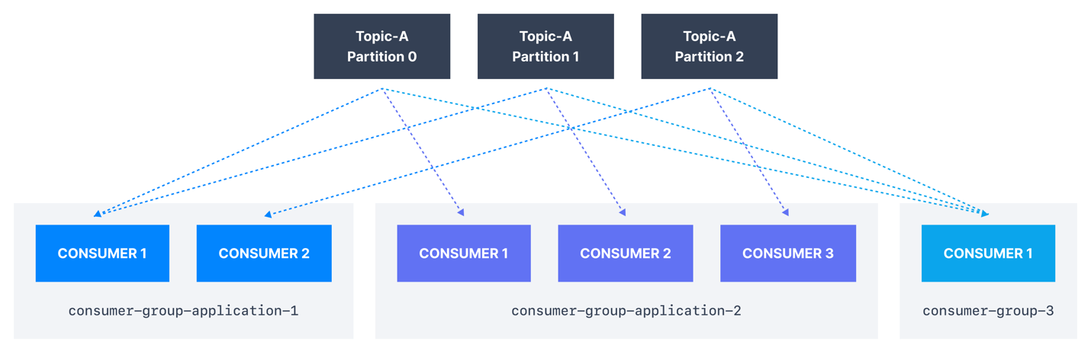

If there are more consumers than the number of partitions of a topic, then some consumers will remain inactive as shown below. Usually, we have as many consumers in a consumer group as the number of partitions. If we want more consumers for higher throughput, we should create more partitions while creating the topic. Otherwise, some of the consumers may remain inactive.

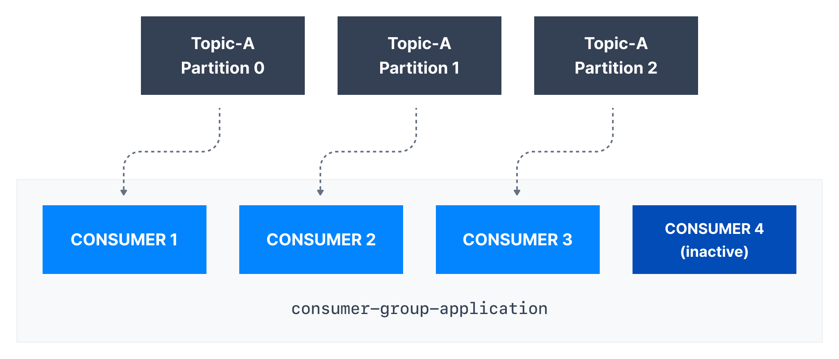

## Kafka Consumer Offsets

## *Consumer offsets behaves like a bookmark for the consumer to start reading the messages from the point it left off.*

Kafka brokers use an internal topic named __consumer_offsets that keeps track of what messages a given **consumer group** last successfully processed.

As we know, each message in a Kafka topic has a partition ID and an offset ID attached to it.

Therefore, in order to "checkpoint" how far a consumer has been reading into a topic partition, the consumer will regularly **commit** the latest processed message, also known as **consumer offset**.

In the figure below, a consumer from the consumer group has consumed messages up to offset 4262, so the consumer offset is set to 4262.

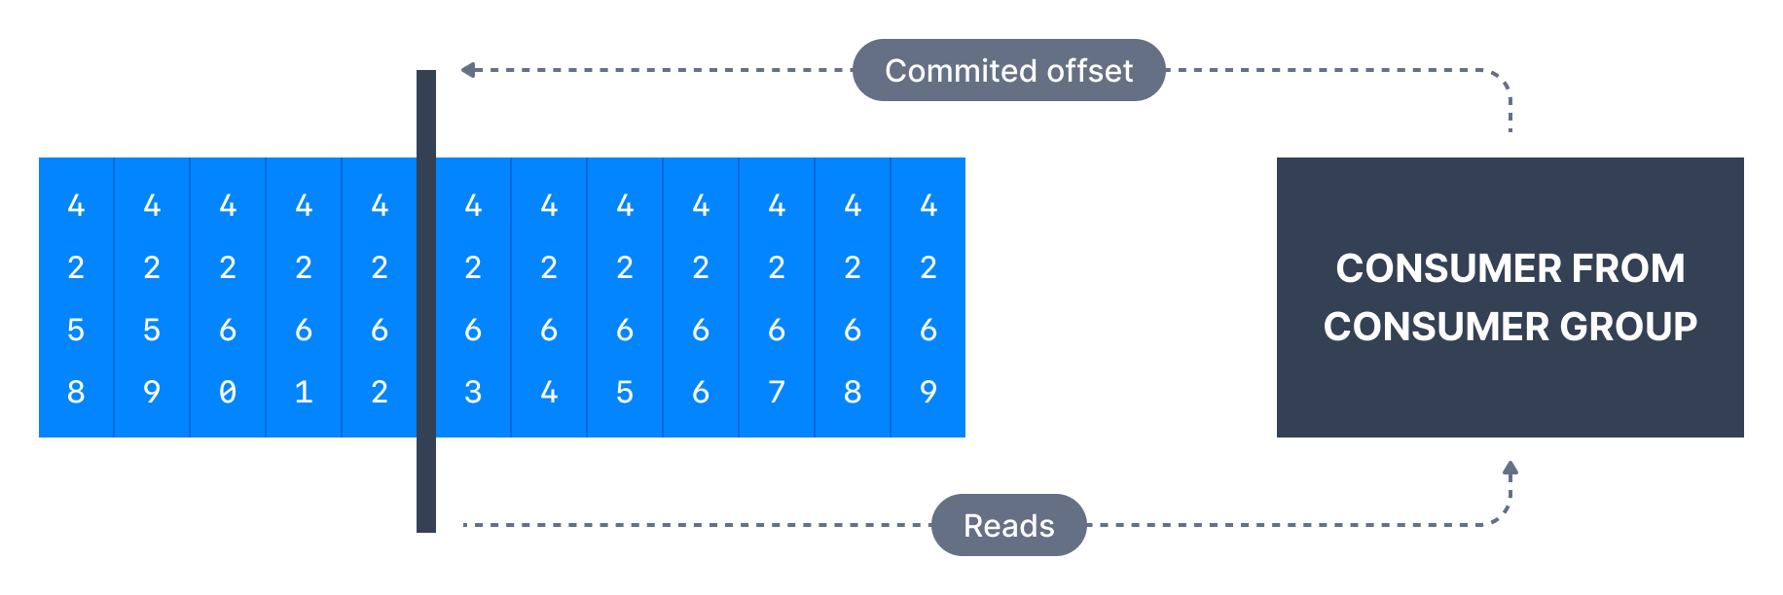

Most client libraries automatically commit offsets to Kafka for you on a periodic basis, and the responsible Kafka broker will ensure writing to the __consumer_offsets topic (therefore consumers do not write to that topic directly).

The process of committing offsets is not done for every message consumed (because this would be inefficient), and instead is a periodic process.

This also means that when a specific offset is committed, all previous messages that have a lower offset are also considered to be committed.

## Why use Consumer Offsets?

Offsets are critical for many applications. If a Kafka client crashes, a rebalance occurs and the latest committed offset help the remaining Kafka consumers know where to restart reading and processing messages.

In case a new consumer is added to a group, another consumer group rebalance happens and consumer offsets are yet again leveraged to notify consumers where to start reading data from.

Therefore consumer offsets must be committed regularly.

### Delivery semantics for consumers

By default, Java consumers automatically commit offsets (controlled by the enable.auto.commit=true property) every auto.commit.interval.ms (5 seconds by default) when .poll() is called.

Details of that mechanism are discussed in [Delivery Semantics for Consumers](https://www.conduktor.io/kafka/delivery-semantics-for-kafka-consumers).

A consumer may opt to commit offsets by itself (enable.auto.commit=false). Depending on when it chooses to commit offsets, there are delivery semantics available to the consumer. The three delivery semantics are explained below.

* At most once:
  + Offsets are committed as soon as the message is received.
  + If the processing goes wrong, the message will be lost (it won’t be read again).
* At least once (usually preferred):
  + Offsets are committed after the message is processed.
  + If the processing goes wrong, the message will be read again.
  + This can result in duplicate processing of messages. Therefore, it is best practice to make sure data processing is idempotent (i.e. processing the same message twice won't produce any undesirable effects
* Exactly once:
  + This can only be achieved for Kafka topic to Kafka topic workflows using the transactions API. The Kafka Streams API simplifies the usage of that API and enables exactly once using the setting processing.guarantee=exactly_once_v2 (exactly_once on Kafka < 2.5)
  + For Kafka topic to External System workflows, to *effectively* achieve exactly once, you must use an idempotent consumer.

In practice, at least once with idempotent processing is the most desirable and widely implemented mechanism for Kafka consumers.

**What is Kafka Broker?**

A single Kafka server is called a Kafka Broker. That Kafka broker is a program that runs on the Java Virtual Machine (Java version 11+) and usually a server that is meant to be a Kafka broker will solely run the necessary program and nothing else.

**What is Kafka Cluster?**

An ensemble of Kafka brokers working together is called a Kafka cluster. Some clusters may contain just one broker or others may contain three or potentially hundreds of brokers. Companies like Netflix and Uber run hundreds or thousands of Kafka brokers to handle their data.

A broker in a cluster is identified by a unique numeric ID. In the figure below, the Kafka cluster is made up of three Kafka brokers.



**Topic Replication**

In a Kafka cluster we have many brokers say we have 3 Kafka brokers and 1 Topic with 2 partitions. Then replication means this partitions will be copied to other brokers. So in event of one broker fails we can still recover data because of replication.

For a given topic-partition, one Kafka broker is designated by the cluster to be responsible for sending and receiving data to clients. That broker is known as the leader broker of that topic partition. Any other broker that is storing replicated data for that partition is referred to as a replica.

An ISR is a replica that is up to date with the leader broker for a partition. Any replica that is not up to date with the leader is out of sync.

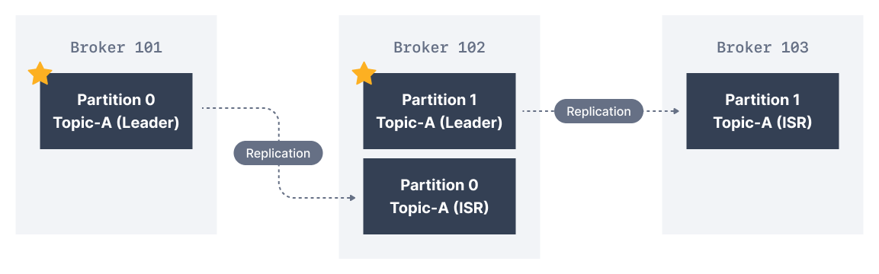

**Zookeeper**

Zookeeper manages brokers i.e. keeps list of them. Zookeeper helps in performing leader election for partitions. Zookeeper sends notifications to kafka in change of new topic, broker dies, broker comes up, delete topic etc. Zookeeper keeps track of health of the brokers and manage cluster for you.

**Kafka with Java**

Add the kafka client dependencies in your spring boot project and creating a producer in the below code.

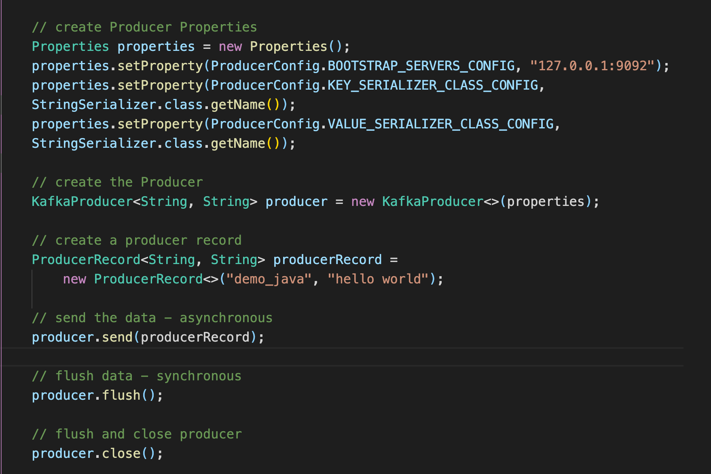

If in a topic there are 3 partitions, and with java code we are producing records fastly and flushing using loops or something, all records will go the same 1 partition because of sticky-partition which is by default in java.

If you want more reference about Producer go to

<https://github.com/conduktor/kafka-beginners-course/tree/main/kafka-basics/src/main/java/io/conduktor/demos/kafka>

**Creating a consumer**

Please look below code to see how consumer is create

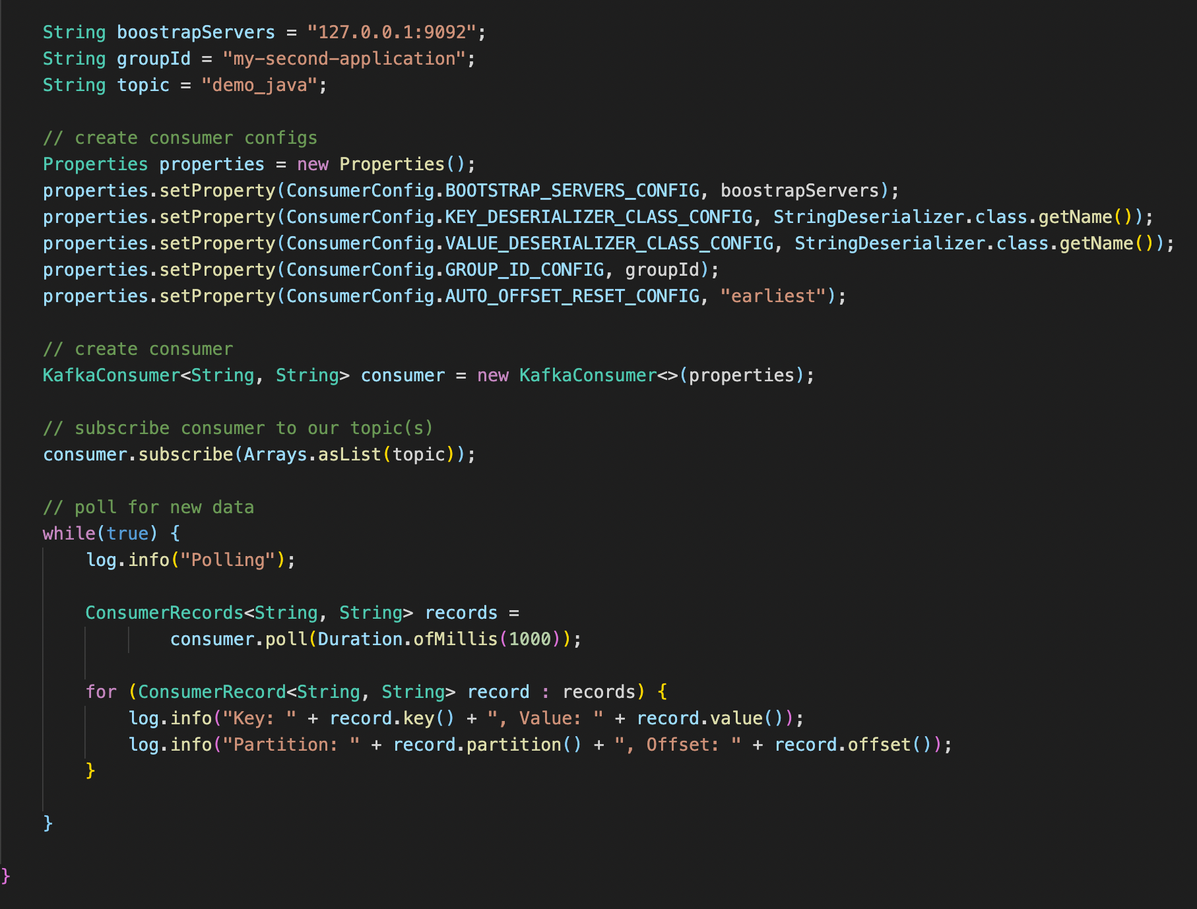

**Spring boot Apache Kafka**

**Kafka Producer:**

Create a Spring boot project by adding dependecies like web, lombok, kafka.

Please look below application.yml file and configurations which are self explanatory.

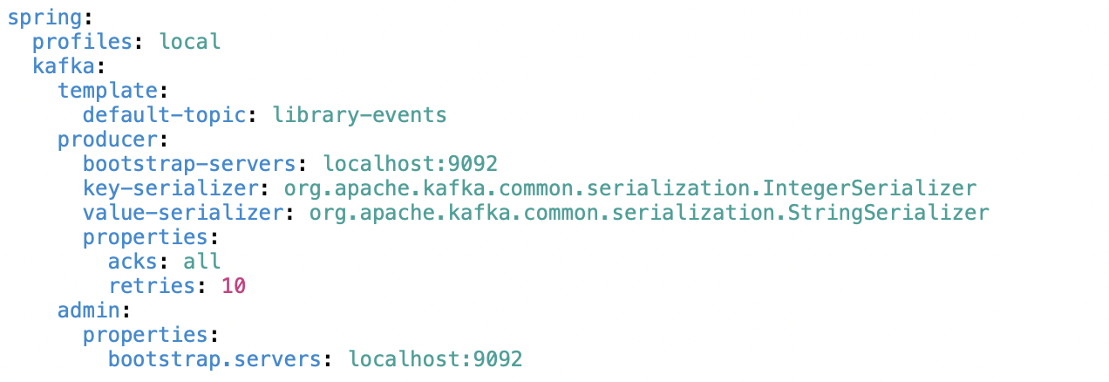

**acks: all** -> guarantees message is written to leader and to all the replicas.

**retries: 10** -> if an error occured in producer which is not related to metadata(kakfa cluster/broker down) then producer retries for 10 times.

**retry.backoff.ms:1000** -> It means after getting an error in a producer, producer retry only after 1000 ms.

**Creating a Topic Programatically:**

It is not recommended to create a topic programatically. But if you want please follow below snippet. And also in above application.yml we gave default-topic.

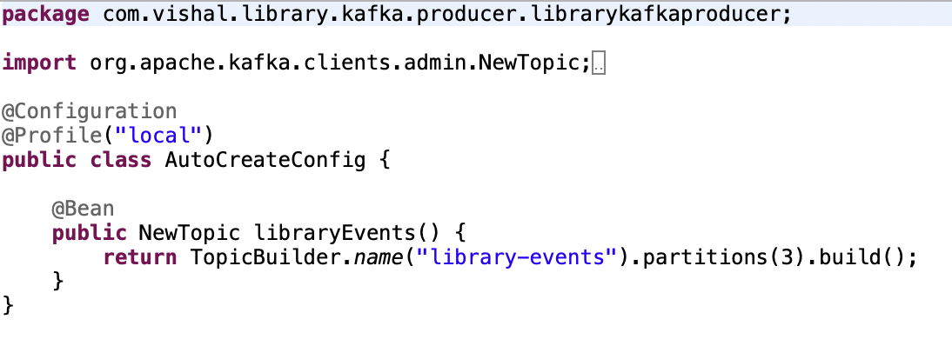

**Creating a Producer config *asynchronosly* approach 1**

First we need a kafkaTemplate, based on the configuration we done in application.yml file, spring will autoconfigure and give us the KafkaTemplate for us, so we can simply do Autowire the KafkaTemplate. Then please see below code for next steps.

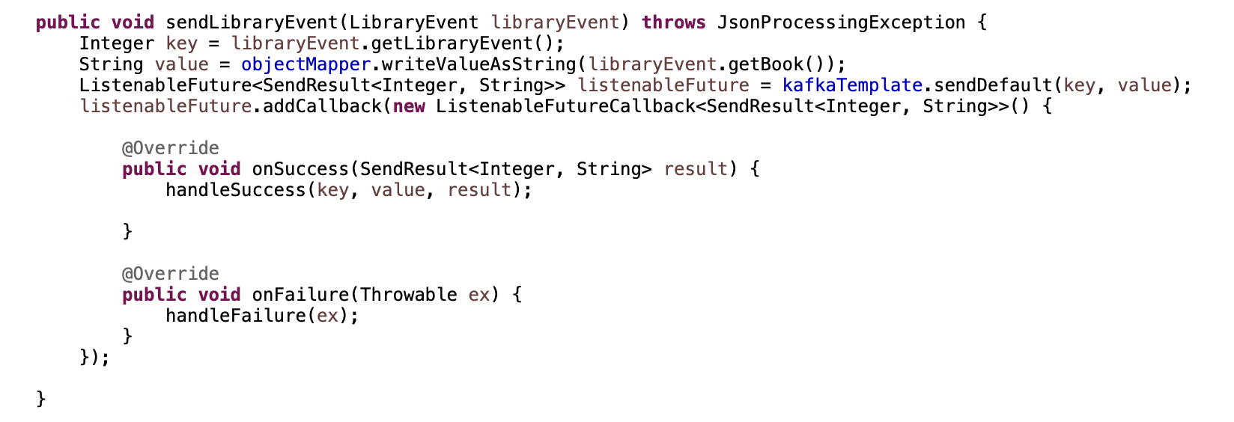

kafkaTemplate has sendDefault method which takes default topic we configured in application.yml file and send the record to kafka broker to default topic. sendDefault method gives listenableFuture on which we can add callback and do all opeartions we want to.

**Creating a Producer config *Synchronosly* approach 2**

In the below code at kafkaTemplate.sendDefault method we added get method which makes it to wait for 1 second and receives the result, so it makes it synchronos.

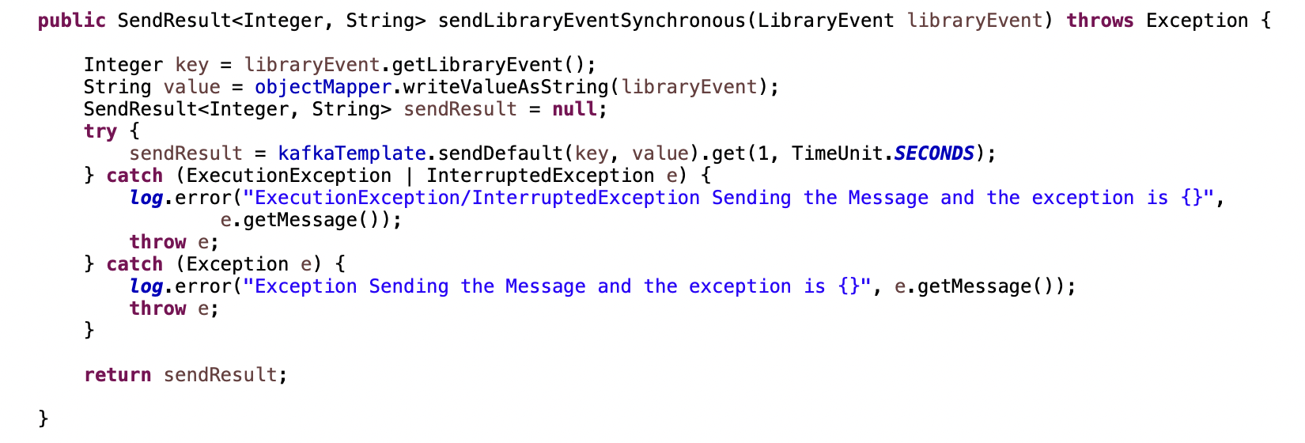

**Creating a Producer config approach 3**

Another way of send record to kafka broker is using ProducerRecord in java. Please look the below code. With this approach we can send Record Headers as well.

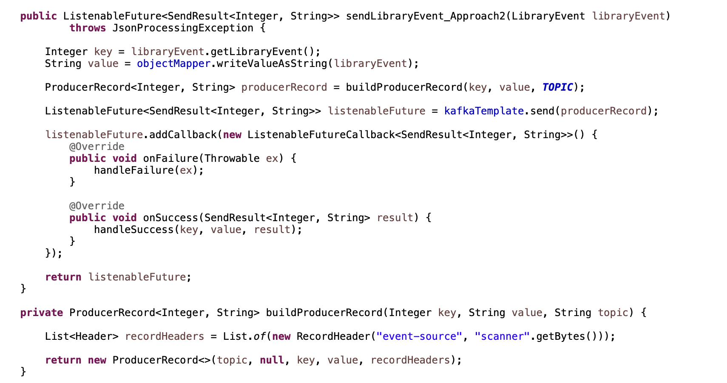

In the above kafka producer example we used key as integer and String as Value. Actually we are converting a object to String and sending to kafkabroker as value which is good because we dont see many errors while consuming in kafka consumer. So my point is use value serializer as StringSerializer.class insted of JsonSerializer so we can get less errors in kafka consumer.

**Kafka Consumer**

From the below application.yml file we can observe that, we configured consumer properties and producer properties which are needed for kafka consumer. Group-id also important for kafka consumer. Because in future when a new consumer instance is up, then the consumer group re-arrange the paritions between available consumers.

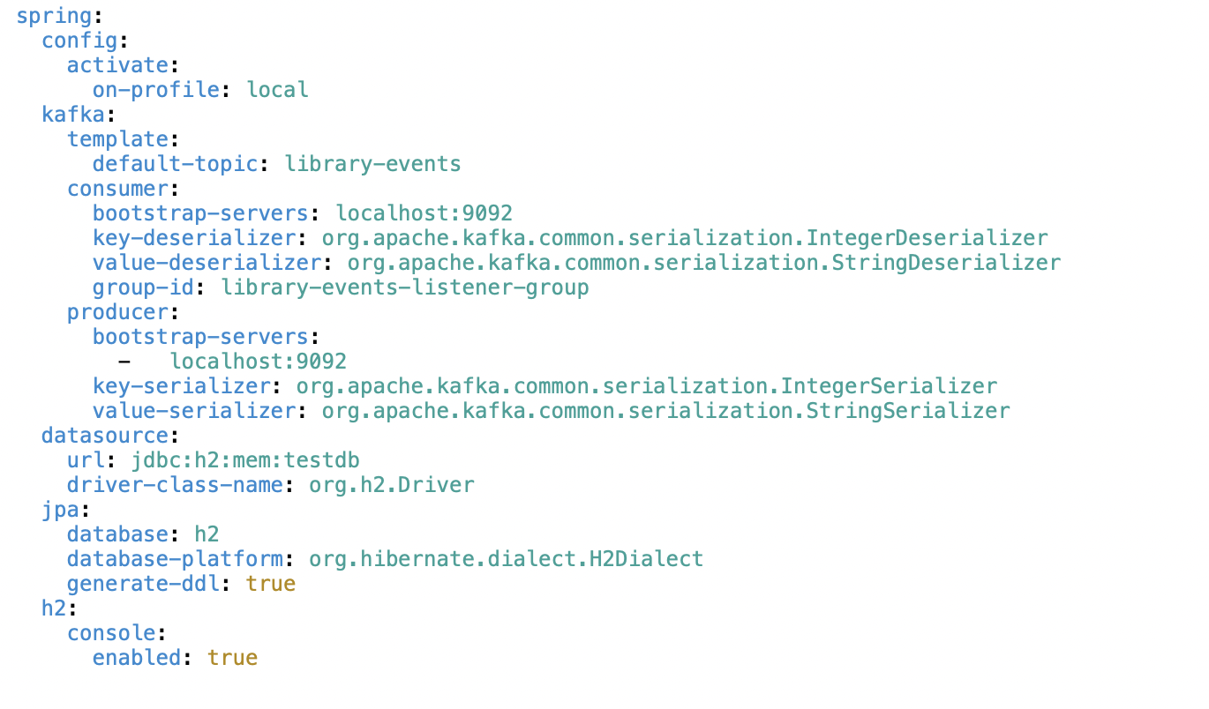

**Different ways to configure the kafka-consumer**

**Approach: 1**

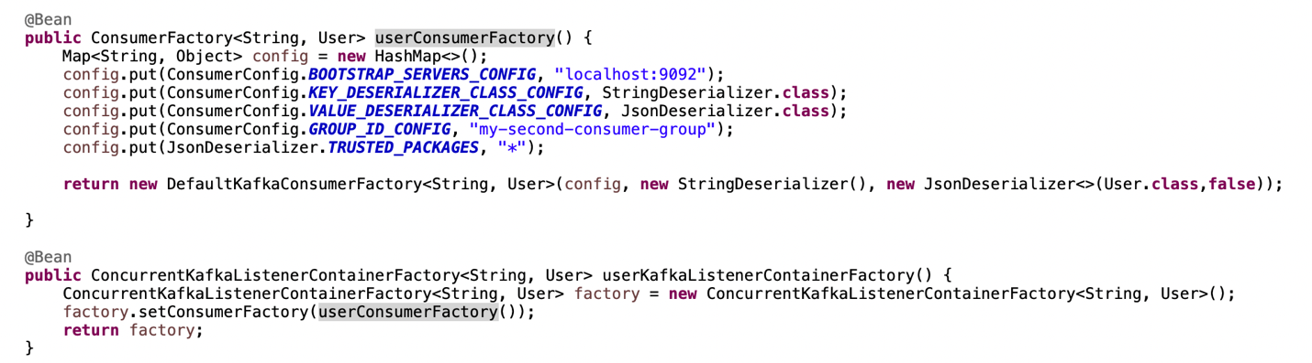

In the above approach we configured all properties programatically, in this case we dont need to write application.yml. In the above we declared two beans i.e. kafkaListenerContainerFactory and consumerFactory beans.

**Approach 2 :**

In the below code we set setConcurrency to 3 which means we start 3 consumer instances for one consumer group, it suits for locally running application.

We set container properties set ack mode to manual, dont do it, default mode is BATCH. Which means records save as a batch to kafka broker.

set error handler method used to handle error when exception occurs.

setRetryTemplate method is used to retry the consume record, we can also configure it to retry a specific kind of exception, it goes along with setRecoveryCallBack method.

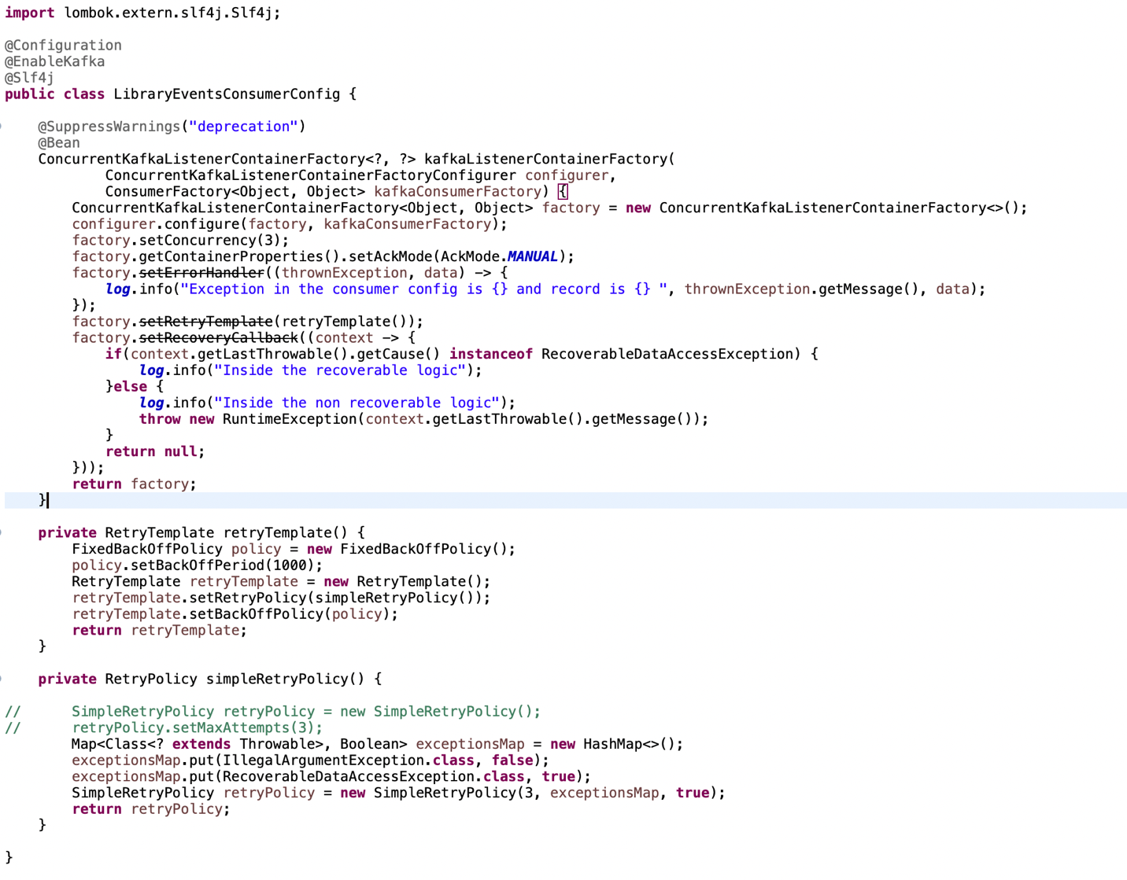

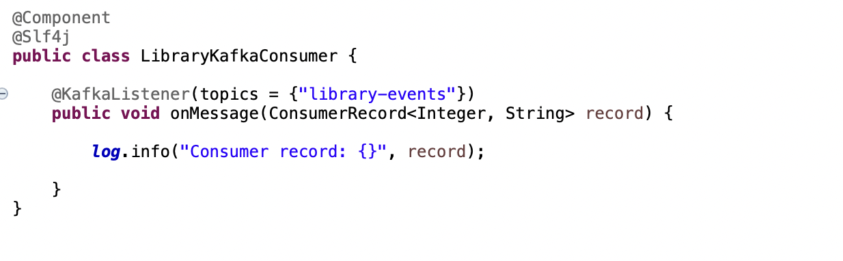

Above code is in which we consume the record from kafka broker. @KafkaListener is annotation which use kafkaConsumerFactory and KafkaListnerContainerFactory to get the things done.